Page numbers starting from a specific page

Start Page Numbering in the Middle of a Document in Word 2010
1 Place the cursor on the page of the document where you want to start numbering. Go to the "Page Layout" tab, click "Breaks" and then click "Next Page" under "Section Breaks."
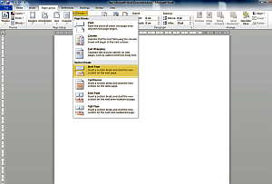
2 Go to the "Insert" tab and select the icon ”Page Numbers”. Choose “Bottom of Page” then “Plain number 2”
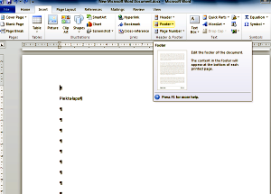
3 Go to the "Design" tab and click the "Link to Previous" button. This will break the link from the previous section and allow you to begin numbering here.
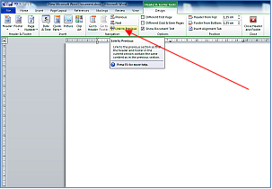
4 Click "Page Number" in the "Header and Footer" section of the "Design" tab and then click "Format Page Number." The "Format Page Number" dialog box will open.
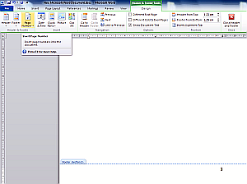
5 Select "Start At" and type the number "1" into the box. Click "OK."

Start Page Numbering in the Middle of a Document in Word 2003
1 Click on the page of the document where you want to start numbering. Go to the "Insert" menu and select "Break." Select "Page Break" in the "Insert Break" dialog box and click "OK."
2 Go to the "View" menu and select "Header and Footer." Click inside the header or footer where you want to start numbering pages.
3 Click the "Link to Previous" button on the "Header and Footer" toolbar. This will break the link from the previous section and allow you to begin numbering here.
4 Go to the "Insert" menu and select "Page Numbers."
5 Click the "Format" button. Type the number "1" into the "Start At" box and click "OK."

